Configuration JDBC and SQL server

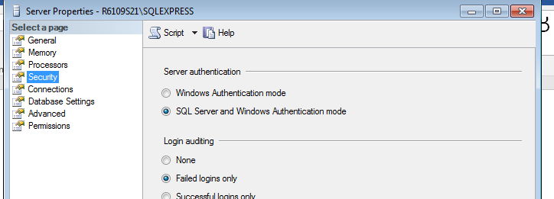

Make sure choosing SQL server

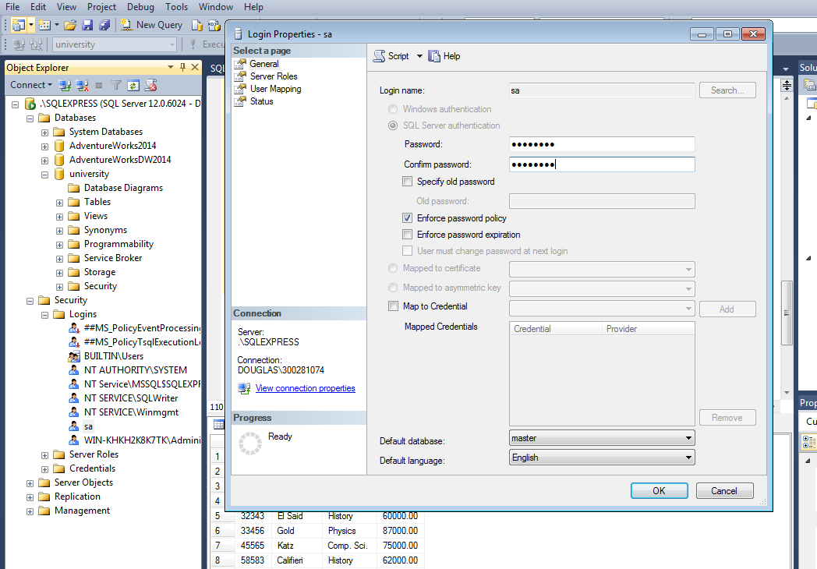

Security -> logins -> sa -> change the password

Then restart the server

Go to PC

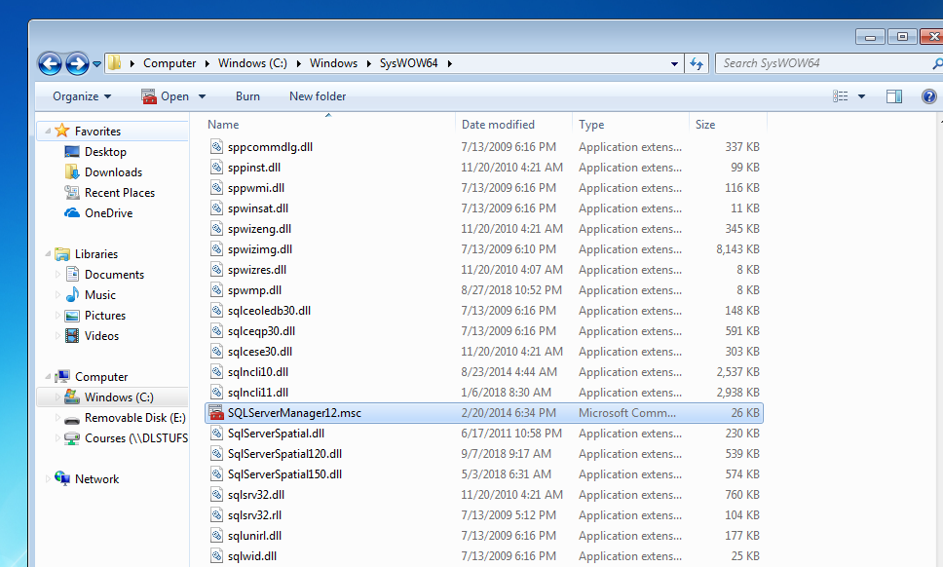

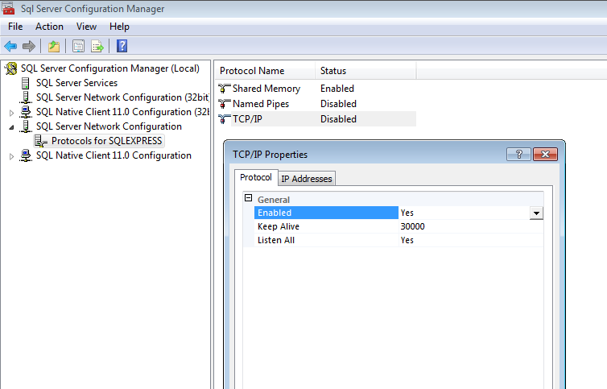

Enable TCP/IP

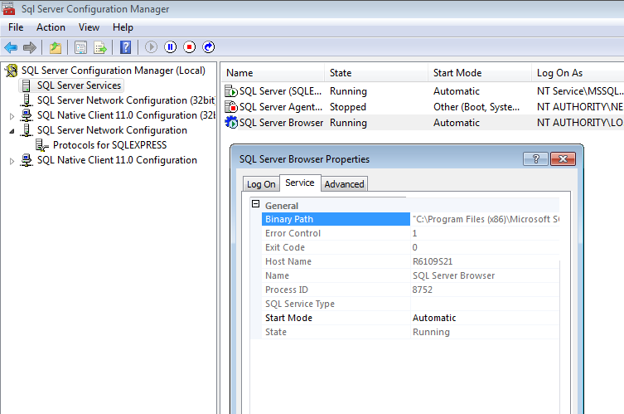

Start mode to automatic

Then restart SQL server

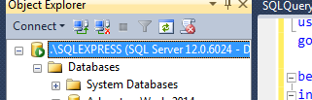 -> instance name: SQLEXPRESS

In java,

Build path => then get jdc jar file for SQL connection

Then create a class, then import all JDBC, then make a connections